**Person**

**Role**

**System**

**Roles Competency**

**Person-Role-System Framework-** The Person-Role-System framework posits that a person’s choices and actions are influenced by who they are as a unique individual and by roles the play(consciously and unconsciously) in different systems. See **figure 1.**

**Boundaries of Authority, Role, and Task (B/ART) –** With the awareness of the Person-Role-System comes the ability to see that in different roles, people have different *tasks* with different levels of *authority* to do those tasks. Most people shift roles many times a day and *unconsciously* reorient their behavior and interactions to each situation. Stated simply, we change our behavior depending on our role and the system it exists within. See **figure 2** for an example of different roles which would influence different tasks and authority levels and notice to overlap. To develop your skill as a Results Based Facilitator, it helps to make the process *conscious* (rather than unconscious) and to provide labels for the limits of authority and tasks in different roles.

**B/ART Tables** – Using a B/ART table can help you consciously explore your own, or other’s, “role-in-system” and the authority, role, and tasks that may accompany a given situation or task.

**Figure 3** is a blank B/ART table.

Source: Bain-Pillsbury, Jolie. Results Based Facilitation. 2013.

**Figure 1**

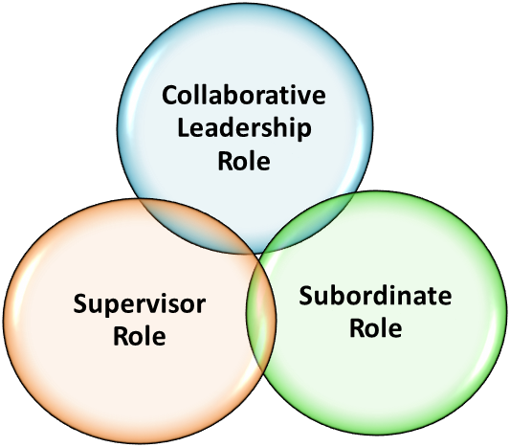

**Person**

**Figure 2**

**Boundary of Authority, Role and Task**

|  |  |  |  |  |  |
| --- | --- | --- | --- | --- | --- |
| **B/ART** |  | **Person/Position A** | **Person/Position B** | **Person/Position C** | **Person/Position D** |
| **Boundary** | Time & Territory |  |  |  |  |
| **of Authority** | The right to do work |  |  |  |  |
| **of Role** | The function of the person |  |  |  |  |
| **of Task** | The work of the group |  |  |  |  |