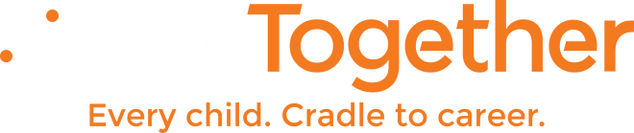
Investment and Sustainability: Engaging Funders in the Vision
Engaging Funders in the Vision:
An Important Step toward Investment and Sustainability

Funding is critical to driving change in our communities. It is easy to see dollars – public or private – as the lifeblood of any initiative’s sustainability. However, it is also easy to look past the larger role that investors can play in collective impact work. In the end, investors can engage in community-wide action in meaningful ways that transcend the traditional roles that have been defined over time that too often focus on putting resources behind individual programs and services.

The role of the investor in quality collective impact work may be harder to quantify when we get beyond dollars and cents, but is critical to building the roots needed to grow sustainable “civic infrastructure” – the organization of all community resources around a single vision with focus on measuring and improving results overtime. If investors are intentionally and actively involved in initiatives focused on long-term solutions to complex social problems, we can maximize the value of their philanthropy and change the paradigm on their role in such work.

To explore how this shift could occur and specifically the key roles investors can play in rigorous collective impact partnerships, StriveTogether collaborated with Grantmakers for Education on “The Role of Investors: Lessons Learned on Critical Roots that Drive Quality Collective Impact”, a paper discussing three key lessons learned from conversations with philanthropists engaged in on-the-ground collective impact initiatives across the country.

We learned that investors can help communities by:
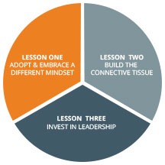
  - Adopting and embracing a different mindset. Quality collective impact requires investors to roll up their sleeves with partners to identify the ways they can best engage to achieve impact. Engaged investors can lead to a dramatic shift in the way investors operate as a collective impact partner in any community.
  - Building the connective tissue. Through their networks, investors can help build the cross-sector connections needed to achieve collective impact and build civic infrastructure.
  - Investing in leadership. Investors experience training leaders within their own organizations can help lift up and support leadership development for those driving collective impact.

Building the Capacity for Impact
Sustainable systemic change requires community-wide support, focused on building the partnership’s ability to make that change. To build the required capacity, cradle to career partnerships have employed two strategies:
- engage investors to secure fiscal donations to support the work; and
- engage partners to secure in-kind donations that support the work by providing resources, services, staff, etc.
Because supports come from different community coffers, it is important for partnerships to quantify and communicate all of the contributions from all partners in the budget, not just the monetary support that passes through the anchor entity.

In the early stages of building a cradle to career partnership, the work is largely focused on relationship building and partnering; the infrastructure needed to support this new way of approaching education reform is just starting to come together. Various committees of cross-sector partners are being formed to carry-out specific work (like communications or strategic direction) and shared outcomes are being identified that the community will agree to hold itself responsible for improving.

Investment doesn’t always have to be in the form of dollars. One of the most important assets a community has is its people and the ability to mobilize them to support practices that move outcomes. Whatever form capacity takes, fiscal or in-kind resources, what is most important is that the capacity is built, sustained and mobilized to have the most impact.

Ecosystem Investing
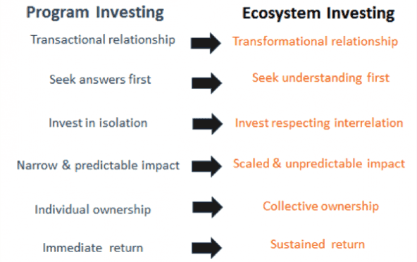
One critical insight we’ve gleaned from our work is that funders seeking impact at scale must view their work within the context of a broader ecosystem and adjust their behavior in response to change within that system. We call this idea ecosystem investing, and it is inherently more complex, requires a different set of assumptions, and produces different results than traditional programmatic investing:
Case Study: Funder Collaboration in Cincinnati and Northern Kentucky
When the StriveTogether network’s first cradle-to-career partnership launched in 2006, the partnership had the backing of KnowledgeWorks Foundation, a Cincinnati-based national education philanthropy. This was both a blessing and a curse for what came to be known as StrivePartnership. It enabled StrivePartnership to launch with a staff and a fairly sizable operational budget and allowed it to take its time in developing its model for improving education outcomes.

StrivePartnership also had some early in-kind support with a loaned executive from Procter & Gamble and several loaned staff from the University of Cincinnati. There were other early funding partners, including United Way of Greater Cincinnati, the Greater Cincinnati Foundation and the Procter & Gamble Fund. But with its operations fully funded, there was no incentive for StrivePartnership to do any early fundraising and so it was not until later in the evolution of the partnership that a broader base of funding partners was needed or pursued.

Several early funding partners were active members of StrivePartnership’s leadership team and were interested in the organization’s idea of aligning funders around common measures:

- United Way, with the launch of its Community Impact Agenda, already had made changes to its funding methodology, organizing around some key focus areas and requiring agencies to demonstrate impact through program evaluation.
- The Procter & Gamble Fund had limited staff and received hundreds of proposals for education reform efforts annually. Many of these proposals were duplicative and not grounded in data. The P&G Fund was looking for more effective and efficient methods for making funding decisions.
- The Greater Cincinnati Foundation, likewise, had invested a significant amount in education initiatives, but was not seeing the return on investment it would have liked.
- The Carol Ann and Ralph V. Haile, Jr./U.S. Bank Foundation, a new independent family foundation, was interested in education issues and willing to take risks.

Each of these partners decided early to align their education funding decisions with StrivePartnership’s endorsement of evidence-based action plans that embraced continuous improvement practices. Gaining the support of additional funders required diplomacy, appreciation for what they have done and a persistent effort at informing them of what the data demonstrates about continuous improvement.

Over time, many local funders agreed to use StrivePartnership as a lens for their funding decisions, but some criticized the partnership for limiting the scope of philanthropic funding in education (i.e. if all funders aligned with StrivePartnership, there would be no funding available for other strategies outside of StrivePartnership’s scope).

In 2008, StrivePartnership convened a small advisory group of funders comprised of the early adopters and a few others who had not yet committed to the model but had demonstrated interest. This group suggested the creation of a Funders Working Group, which led to greater awareness but minimal results in changed funding behavior.
In 2009, StrivePartnership attempted to launch a more traditional fundraising campaign, in partnership with the Greater Cincinnati Foundation. Investors were not comfortable donating to a pooled fund without clear priorities and outcomes. This feedback pushed StrivePartnership to engage in comprehensive strategic planning, to narrow its focus and to more clearly link strategies to the outcomes of StrivePartnership’s annual report card. The partnership developed white papers on specific priorities where strong data-based evidence existed and targeted funders with specific interest in these areas to raise grant funding for specific Collaborative Action Networks.

Around the same time, the Edward M. Kennedy Serve America Act was signed into law, establishing a $50 million federal Social Innovation Fund. StrivePartnership and the United Way of Cincinnati partnered on an application and their request for a two­ year, $2-million grant was approved. The grant required a 1-1 match with local funds and this time around, StrivePartnership had much more success in recruiting partners for the pooled fund. By contributing to the pool of funding, the funders did not lose their decision-making authority or autonomy. Rather, the funders who contributed at least $25,000 were invited to participate as part of the SIF Oversight Committee, which made decisions about the application process and reviewed and made decisions on applications. The Cincinnati/Northern Kentucky SIF program therefore was structured around a few very specific outcome areas: kindergarten readiness, fourth-grade reading, high school graduation and college preparedness, postsecondary enrollment and completion, and sustained employment. Applicants had to demonstrate effective community solutions that improve outcomes in one or more of those areas.

Lessons Learned:
- Seek out Innovators and Early Adopters as the first funders to engage in the work, as well as loaned executives and in-kind resources to get you started.
- Early fundraising strategy should focus on very targeted requests. Research potential funders’ areas of interest and approach them for targeted grants to support one or more aspects of a Collaborative's action plan. Focused meetings with funders are opportunities to help them understand the aligned and evidence-based model, but put early energy into advocating for support of specific strategies and actions.
- Respect funders’ timelines, processes and governance structures. Provide funders with clear data and goals. to allow them to more easily coordinate their efforts with the partnership’s goals.
- Allow funders to maintain authority in funding processes. Engage them through participation on an oversight committee or some other structure within the partnership's governance structure.
- Be very clear in communications with providers and the funding community about your goals and methods. Use the focus on outcomes and increased return on investment as a selling point for funders. Help providers clearly understand the role of the partnership in advocating for their work, but do not guarantee funding.

